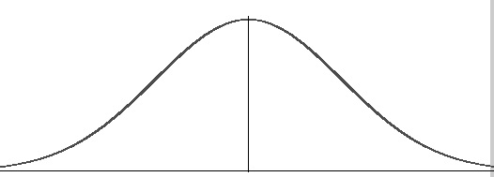

Nonlinear transformation

f



Sigma Point Matrix

dn x d2n + 1

Transformed SPM

dx x d2x + 1

+

Calculate Weights

1

n

n



]

Transformed Prediction

Transformation (h)

Calculated Weights



Calculated Weights +



=